|  |  |
| --- | --- |
| FINALLOGO | **Anjalai Ammal - Mahalingam Engineering College, Kovilvenni,**  **Thiruvarur (D.t) – 614 403**  **Department of Information Technology** |

**RIDGE CONTROL AND CROP MANAGEMENT USING AURDINO**

**FIRST REVIEW**

**Batch Number : 3**

**Project Batch Members:**

**P. ASRAF HUSSAIN - 820417104009**

**G S. GOVINDASAMY - 820417104015**

**A. MOHAMED AJEEM - 820417104030**

**Guided By**

**Mr. R. RAMA RAJESH M.E,**

**Assistant Professor,**

**Department of IT,**

**AAMEC.**

**Signature of the Guide Signature of the Project Coordinator**

**ABSTRACT**

Internet of Things (IOT) plays a crucial role in smart agriculture. Smart farming is an emerging concept, because IOT sensors capable of providing information about their agriculture fields. This Project aims making use of evolving technology i.e. IOT and smart agriculture using automation. Usually the farmer pumps the water more or less to cultivate the land. One more type of IOT product in agriculture and another element of precision farming are crop management devices. Just like weather stations, they should be placed in the field to collect data specific to crop farming from temperature. By using soil moisture sensor, Devices gets an alerting message when the moisture level increases or decreases. Also when the water level is too high, there is a separate machine which acts like a ridges, and opens the door for water to go through other fields. If the water level is sufficient for the crops or soil, the machine locks the ridges, stores the water for crops. In this work we can able to rectify the problem, without man power the machine act like a man and makes the ridges automatically based on the water consumption. By using soil moisture sensor, we can also able to get updates about the soil and water level management. We can also add humidity check and machine that flow water to the plants when it needs by using sensors.

**BASE PAPER**

|  |  |  |  |  |
| --- | --- | --- | --- | --- |
| **S.No.** | **Paper Title, Author Name and year of publication** | **Concept** | **Advantage** | **Disadvantage** |
| **1.** | **TITLE:**  Soil Moisture, Temperature and Humidity Measurement Using Arduino  **AUTHOR:**   * Prahlad Bhadani * Dr. Vasudha Vashisht   **PUBLICATION:**  9th International Conference on Cloud Computing, Data Science & Engineering (Confluence) | The device measures three of the most important and basic parameters for growth of plants namely soil moisture, temperature and humidity.  The sensors read the data and send it to the microcontroller board. The board then processes and maps the  data as per the code, and finally displays it on the LCD unit. | * To provide smart farming techniques to Indian farmers. * The portability and cost issues and providing reasonably accurate values during measurement. * Hobbyists and people who grow crops in their backyards can also use this device to effectively make their gardening decisions. | * It is a wholesome involvement of computer programming and hardware interaction Creativity and necessity can find unlimited possibilities in the field of Arduino projects. * Need some skill full persons. |

|  |  |  |  |  |
| --- | --- | --- | --- | --- |
| **S.No.** | **Paper Title, Author Name and year of publication** | **Concept** | **Advantage** | **Disadvantage** |
| **2.** | **TITLE:**  Smart Farm Monitoring via the Blynk IoT Platform  **AUTHOR:**   * Peerasak Serikul * Nuttapun Nakpong * Nitigan Nakjuatong   **PUBLICATION:**  2018 Sixteenth International Conference on ICT and Knowledge Engineering | This smart capsule used Node MCU ESP8266 microcontroller and the  SHT21 humidity sensor to send data to the Blynk server over a Wi-Fi network. | * According to the research results, the Blynk mobile application could work well on Android and iOS. * line graph comparing the humidity data. | * Reducing the   size of smart capsules so as to increase space for paddy storage.   * installing a humidity meter outside a paddy bag for easier   installation and removal. |
| **3.** | **TITLE:**  Automatic Plant Irrigation System using Arduino  **AUTHOR:**   * Devika CM * Karthika Bose * Vijayalekshmy S   **PUBLICATION:**  2017 IEEE International Conference on Circuits and Systems | An automatic plant irrigation system has to be designed for the  proper water supply in the fields. | * Conserves water and eradicate the presence of workers for watering their agriculture fields completely, since the pumping technology is automatic. | * In Dry areas, where there is no sufficient rainfall, proper irrigation is not possible and water supply is required. |

|  |  |  |  |  |
| --- | --- | --- | --- | --- |
| **4.** | **TITLE:**  A Low-Cost Arduino based Automatic Irrigation System using Soil Moisture Sensor: Design and Analysis  **AUTHOR:**   * Divya Dhatri PVS * M Pachiyannan * Jyothi Rani K * Pravallika G   **PUBLICATION:**  2019 International Conference on Signal Processing and Communication | The usage of a low cost Arduino based automatic irrigation system using soil moisture sensor is expected to be useful to for the irrigation process in agriculture | * It Consumes less amount of water. * This watering is done considering different parameters like weather conditions, type of plant and type of soil. | * It Requires low maintenance regularly. * We need to fetch data to this system before implementation. |
| **5.** | **TITLE:**  Monitoring moisture of soil using low cost homemade Soil Moisture Sensor and Arduino UNO  **AUTHOR:**   * Matti Satish Kumar * T Ritesh Chandra * D Pradeep Kumar   **PUBLICATION:**  2019 International Conference on Signal Processing and Communication | we present a method to manufacture soil moisture sensor to estimate moisture content in soil hence by providing information about required water supply for good cultivation. | * Soil moisture sensors have significant role in implanting smart irrigation systems and telemetry systems. * Soil moisture sensors protect water resources and understand our ever changing climate. | * As many as 6 sensors can be used simultaneously to reach maximum accuracy using Arduino UNO, But the cost of setup is too high and maintenance also high. |

|  |  |  |  |  |
| --- | --- | --- | --- | --- |
| **6.** | **TITLE:**  Arduino-Based Smart Irrigation Using Water Flow Sensor, Soil Moisture Sensor, Temperature Sensor and ESP8266 WiFi Module  **AUTHOR:**   * Pushkar Singh * Sanghamitra Saikia   **PUBLICATION:**  2016 IEEE Region 10 Humanitarian Technology Conference | The designed system deals with various environmental factors such as moisture, temperature and amount of water required by the crops using sensors like water flow sensor, temperature sensor and soil moisture sensor. | * The controlling system consume very low energy which allows system to work continuously for several months on a single 9 V battery. | * We need to fetch data to the system using databases. * Maintenance is required. |
| **7.** | **TITLE:**  Arduino based soil moisture analyzer as an effective way for irrigation scheduling  **AUTHOR:**   * Seeralakandapalan Sayanthan * Tharmarajah Thiruvaran * Nadarajah Kannan   **PUBLICATION:**  2019 International Conference on Signal Processing and Communication | It was calibrated with direct moisture meter to obtain the moisture readings directly by using this soil moisture sensing technique it is possible to save a huge amount of water. | * With the assistance of an Arduino based device the crop water requirements were calculated for the different stages of eggplant such as 18 days after planting. | * This is fully automated so we need men with higher skills. * We need database to access data. |

|  |  |  |  |  |
| --- | --- | --- | --- | --- |
| **8.** | **TITLE:**  Automatic Plant Monitoring System  **AUTHOR:**   * K. Krishna Kishore M. * H. Sai Kumar * M. B. S. Murthy   **PUBLICATION:**  International Conference on Trends in Electronics and Informatics ICEI 2017 | A mechanism is established to find the moisture content in the soil with the help of soil moisture sensor and depending upon the condition of the sensor the water is controlled | * This helps in irrigating the field even during night time, so does not require the farmer to switch ON the motor manually | * In the Night time, the power management system does not saves power automatically. * Threshold value varies depending upon situation |
| **9.** | **TITLE:**  Improved Durability of Soil Humidity Sensor for Agricultural IoT Environments  **AUTHOR:**   * Young Ju Jeong * Kwang Eun An * Sung Won Lee * Dongmahn Seo   **PUBLICATION:**  2018 IEEE International Conference on Consumer Electronics | From rusting of sensors, wrong information of soil humidity can be collected on smart farm system based on agricultural IoT Environments. It makes that smart farm is not reliable | * It makes that smart farm is not reliable. * We propose a new type of soil humidity sensor in order to extend life time. | * Sometimes the data value sensors gives chopsticks value differently. |

**ISSUES IN THE EXISTING SYSTEM**

* The existing literature suggest that crop management only indicates the detail of water level and plant consumption.
* There is no sign of additional any machine that act accordingly to situation that depends on what the plant needs in water consumption.

**FEATURES OF THE PROPOSED SYSTEM**

* In this work we can able to rectify the problem, without man power the machine act like a man and makes the ridges automatically based on the water consumption.
* By using soil moisture sensor we can also able to get updates about the soil and water level management.
* We can also add humidity check and machine that flow water to the plants when it needs by using sensors.

**PROBLEM IDENTIFICATION**

* There is a separate machine which acts like a ridge, and controls the door for water to enter and leave the fields based on requirement.
* If the water level is sufficient for the crops or soil, the machine locks the ridges, stores the water for crops.
* Without man power the machine act like a man and makes the ridges automatically based on the water consumption.
* By using soil moisture sensor, we can also able to get updates about the soil and water level management.
* We can also do humidity check and machine can control the water flow to the plants when it needed by using sensors.

**REQUIREMENTS SPECIFICATION**

**Materials and methods**

1. Arduino Genuino Uno
2. Soil Moisture Hygrometer Sensor (FC-28)
3. Temperature and Humidity Sensor (DHT11)
4. Stepper Motor 6A Single Shaft
5. Mechanism Opening and Additional Sensors

**Software requirements**

1. Python 3.9.15
2. Python 3.7.5 if any
3. Anaconda 1.1.0v for modules
4. Juypyter 6.1.6
5. SQL Software (PostgreSQL)

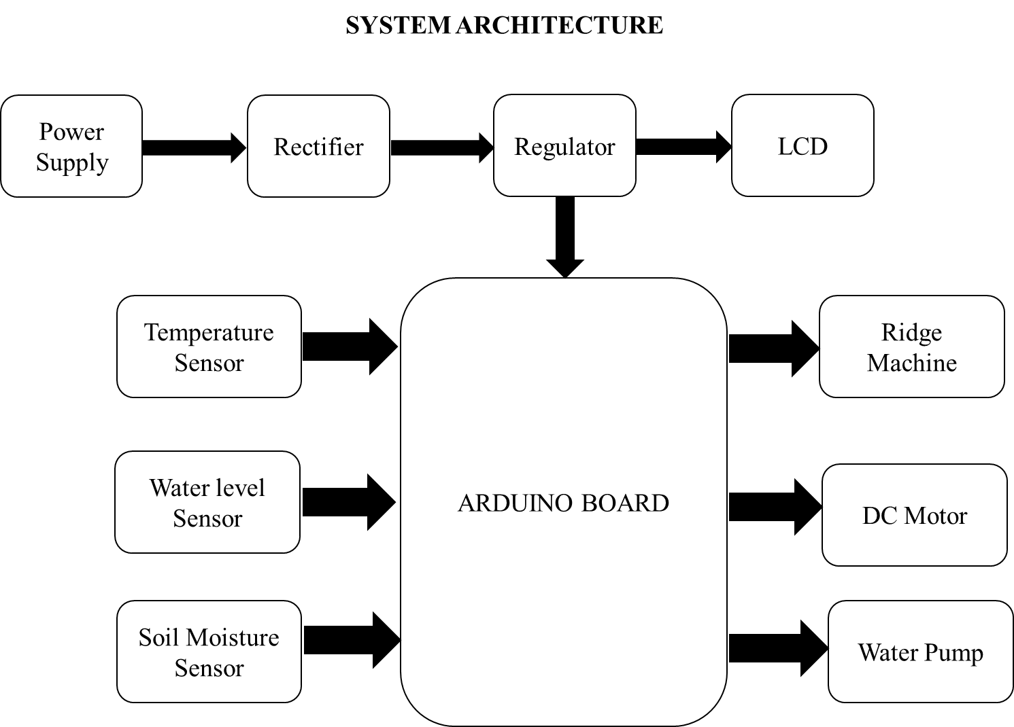

**LIST OF MODULES**

* ***Water level monitoring sensors*** The water level will be captured from the ***water level sensors*** and soil moisture sensors. When the water level is low the ridges will be in closed condition so that the water reaches a standard level for the plants. If the water level is too high the door opens for the water to leave the fields.
* ***Ridge control module*** The proposed mechanism acts like ridges. It opens up when the water level of the fields is too high, without the man power the machine acts like a door and gives a way for the fields. ***6A Single Shaft 1.8 Degree Stepper motor:*** Brushed DC motors rotate continuously when DC voltage is applied to their terminals. The stepper motor is known for its property of converting a train of input pulses (typically square waves) into a precisely defined increment in the shaft’s rotational position. Each pulse rotates the shaft through a fixed angle. Stepper motors effectively have multiple "toothed" electromagnets arranged as a stator around a central rotor, a gear-shaped piece of iron. The electromagnets are energized by an external driver circuit or a micro controller.
* ***Water Pump module,*** A Dc motor is used with the pump. By activating the motor driver circuit by the read value of the Arduino board with the set reference value, the pump will automatically turn on and turn off.
* ***Temperature sensing module,*** The Uno from Arduino is an open source board, also referred to as a microcontroller board. It is based on the “ATMega328P” microcontroller board. Arduino.cc developed this board. There are digital and analog pins for input/output. The board has 14 digital and 6 analog pins. The programming software that is used to program the board is the Arduino IDE. A Type-B USB cable is used to connect the Arduino board to the computer system. Two probes estimate the volumetric content of water in the soil. Current passes through the soil and then through the probes, after which the moisture value is calculated based on the resistance offered. In more water, soil becomes more conductive and which means resistance decreases. Therefore, moisture value displayed is higher. It has a humidity measuring module, a thermistor and an integrated circuit on the back of the sensor unit. The humidity measurement module consists of two electrodes. Sandwiched between the two electrodes is a substrate that is capable of holding moisture.
* ***Moisture sensing module*** , we will be able to get the details about the field and crops. Water level is the main concept of our project. Maintaining water level for the crops and fields are off very important so as to maintain the health of the crops.